Assignment 3 Linear Regression with Weka 3.9 2020

Data Pre-processing: Creating an ARFF file

Exercise 1:
  - Open file BostonHousing.xls and save it in Comma-separated format
  - Open file BostonHousing.csv in Notepad

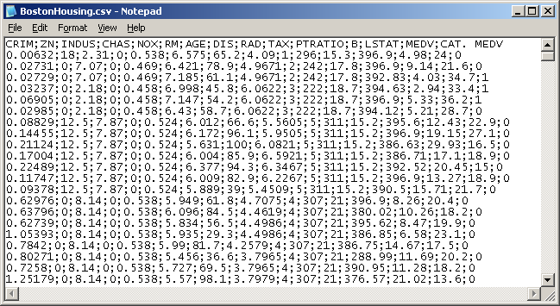

  - Change the beginning of the file as shown below:

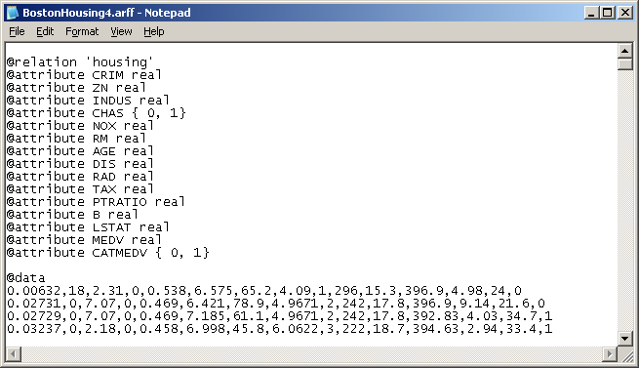

Note: Make sure that the data values are separated with comma

  - Save the file with extension .arff

Classification methods in WEKA
General instructions for working with WEKA:
- Start WEKA (Start menu /Programs) and press “Explorer” button
- In order to open a file (dataset) use Preprocess tab and Open File… button.
- To change a classifier click on the "Choose" button in the Classifier field.
- To run a classifier press Start button.

Remark: You can look at the results from the different exercises by switching over “Result List” window on WEKA Explorer screen.

Exercise 2:

The file BostonHousing.xls contains information collected by the U.S. Bureau of the Census concerning housing in the area of Boston, Massachusetts. The dataset includes information on 506 census housing tracts in the Boston area. The goal is to predict the median house price in new tracts based on information such as crime rate, pollution, and number of rooms. The data set contains 14 predictors, and the response is the median house price (MEDV). Table 5.1 describes each of the predictors and the response.

Table 1. Description of Variables for Boston Housing Example

CRIM per capita crime rate by town
ZN proportion of residential land zoned for lots over 25,000 sq.ft.
INDUS proportion of non-retail business acres per town.
CHAS Charles River dummy variable (1 if tract bounds river; 0 otherwise)
NOX nitric oxides concentration (parts per 10 million)
RM average number of rooms per dwelling
AGE proportion of owner-occupied units built prior to 1940
DIS weighted distances to five Boston employment centres
RAD index of accessibility to radial highways
TAX full-value property-tax rate per $10,000
PTRATIO pupil-teacher ratio by town
B 1000(Bk - 0.63)^2 where Bk is the proportion of blacks by town
LSTAT % lower status of the population
MEDV Median value of owner-occupied homes in $1000

A. Why should the data be partitioned into training and validation sets? What will the training set be used for? What will the validation set be used for?

In Weka, run a linear regression model to the median house price (MEDV) as a function of CRIM, CHAS and RM.

B. Write the equation for predicting the median house price from the predictors in the model.

MEDV = -0.2607 * CRIM + 3.763 * CHAS=1 + 8.2782 * RM + (-28.8107)

C. What median house price is predicted for a tract in the Boston area that does not bound the Charles River, has a crime rate of 0.1, and where the average room per house is 6?

20.83243

